Come Dance With Me / DANCE USA

June 18, 2013

Body and Brain Connections
By Veronica Hackethal
Ask most dance teachers, and they will tell you that dance ignites an internal fire in those susceptible to it. Dance is a form of communication that enables self-expression and encourages social connection when other forms of communication fail. As a transformative experience, dance has been linked to health and healing throughout history and across cultures. Shamans use dance and trancelike states to promote healing and recovery. Ancient Greek physicians recognized the importance of dance for improving physical health, promoting academic achievement, and encouraging social interaction. This ancient knowledge has extended into the present day. Various forms of dance are currently used in many different settings to promote health and wellbeing, including medical and mental health facilities, schools, and community centers. How are we using dance today to promote health and wellbeing?

The Wisdom of Experience: Dance Teachers
During more than 35 years of teaching ballet in New York City studios like Steps on Broadway, Ballet Arts at City Center, and Broadway Dance Center, Dawn Hillen has seen it all. A former principal dancer with the American Festival Ballet, Wilkes-Barre Ballet Theatre, Classical Ballet Theater in Maryland, and Contemporary Ballet Theater in New York City, she has taught all age levels, from preschoolers to people over age 65, and has coached teenagers for dance competitions. She has guest taught throughout the country, and has also pursued training in leadership and personal development.
Hillen emphasized that dance, especially ballet, teaches discipline and enhances personal well-being. “If you can do ballet, you can do anything. It’s like a positive channeling of the energy of how to create yourself,” she said. “I don’t know how to measure the impact of the sheer joy of it. The absolute joy in the moments of flying through the air are so deeply uplifting that you can’t help but feel better. And in feeling better, you feel better about yourself.”
In response to criticisms that ballet encourages a relentless pursuit of perfection, especially in teenage girls, that can damage the ego, Hillen took pains to emphasize the value of good teaching: “It’s critical for the teacher to be positive, to come at it with love and joy. If the teacher only focuses on correcting to perfection, then sometimes it’s actually detrimental. Equally important is where the student is emotionally [when] coming into ballet. If she comes in with a shaky internal structure, she’s going to need a really loving teacher. I think if we stop teaching competitively and support the individuality, we can build better dancers. It’s always people who are uniquely themselves who become the best at what they do.”
Hillen described how dance teaches life lessons to young people. “In my opinion ballet prepares you to meet and pass any obstacle. Every day, you have to mentally and physically conquer yourself. If you look at what girls do after dance, a number of them do really super things. They know how to put their negative ego in check and pursue what they’re after. They know how to show up every day, whether they like it or not. Dancers can take directions. After awhile, because they can take directions, they may also know how to give directions.”
She went on to explain how dance training during the formative years can lay the groundwork for future success. “First of all, ballet gives teenagers a place to be so that they don’t get involved in other things that are less healthy,” Hillen said. “Being able to set out to accomplish something and, within an hour and a half actually do it, is tremendously beneficial for teens. There is immediate gratification in terms of the sense of personal accomplishment.”
Hillen also believes that dance training is important in molding the developing brain. “The way the music goes into teenagers’ brains as the brain is still forming, the way they need to coordinate with it, and with each other, builds a brain that is more complex than the brain of someone who doesn’t have to meet all those challenges,” she explained. “I think it sets the individual apart later in life, because they can handle so many things.”

This Is Your Brain on Dance
Only recently has science tried to analyze how dance benefits the brain and brings such joy. One theory holds that, like most exercise, dance releases a cascade of feel-good chemicals in the brain. Dancing induces the release of endorphins, the body’s natural pain killers that increase pain tolerance and boost mood. Endorphins are responsible for the euphoria experienced during a “runner’s high” and have a similar effect on the body during dancing.
Dancing increases the brain levels of serotonin and norepinephrine, two neurotransmitters that smooth out negative emotions. Norepinephrine also helps increase attention and mental focus. Dancing also increases the brain levels of serotonin and norepinephrine, two neurotransmitters that smooth out negative emotions. Norepinephrine also helps increase attention and mental focus. In addition, moving to music while we dance activates the brain’s pleasure circuits. Dancing can even induce the production of proteins that increase the growth of new neurons in the brain. Dancing also helps lay down new synapses, or connections, between neurons. Both processes can increase neuroplasticity, or the ability of the brain to change and adapt to new environments, behaviors, and even recover from injury.
Dancing activates both sides of the brain, a process that promotes brain integration and improves learning. Many regions of the brain are required to remember, plan, and produce the coordinated movements that enable us to dance to music and rhythm. The cerebral cortex, the largest area of the brain, makes us human: it enables us to experience emotions, plan our movements and behavior, and engage in complex thinking. A region of the cerebral cortex called the motor cortex plays a major role in planning, control, and execution of voluntary movement. The motor cortex has at least five areas that are important for dancers. The posterior parietal cortex interprets and helps plan movements in response to multiple sensory inputs, like vision and hearing. The premotor cortex integrates sensory and spatial input to plan and guide movement. The supplementary motor area plans complex movements, especially sequential movement and coordination of both sides of the body. The premotor and supplementary motor cortex communicate with the primary motor cortex, which in turn produces nerve signals that travel down the spinal cord and tell the muscles how to execute movement.
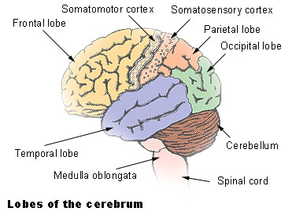The basal ganglia are two areas that lie below the motor cortex in the brain and play important roles in regulation and relay of information necessary for voluntary movement. The basal ganglia also play a role in cognitive and emotional functions. Damage to the basal ganglia contributes to many of the symptoms of movement disorders, like Parkinson’s and Huntington disease. The basal ganglia are also part of the limbic system, which contains the brain’s pleasure center. An area of the basal ganglia called the thalamus is a somatosensory relay center that contains neurons directly connected to the hippocampus, which can turn on the brain’s pleasure center. The hippocampus also plays an important role in memory and spatial navigation. Two other areas of the basal ganglia called the caudate and putamen are important for learning, memory, and regulating movements.
Other brain areas also play important roles in dancing. The cerebellum is the bun-like area at the back of the brain and plays a role in fine-tuning movement, coordination, and balance. The primary somatosensory cortex receives and interprets sensory information from all over the body. This area is depicted by the cortical homunculus, which is basically a drawing that shows which areas of the brain are dedicated to different body parts. In these types of drawings, depictions of body parts look cartoonish, and heavily used body parts are drawn much larger than infrequently used ones. When one body part is used a lot, such as the hand of a pianist, or the foot of a ballet dancer, new neural connections sprout. The area of the brain dedicated to the heavily used body part expands in proportion to the increased innervation. In the case of a dancer, the corresponding representation in the cortical homunculus would be a very large foot. In “The Neural Basis of Human Dance,” published in 2006 in the journal Cerebral Cortex, Brown and colleagues did PET scans of the brains of dancers while they executed tango steps on a footboard. Overall, the researchers found a great deal of coordination among different brain areas, and a trend for right-brain dominance. Though there is much overlap in function between the two sides of the brain, as well as variation between individuals, the general thinking goes that the left side handles analytical functions, while the right side handles artistic ability. The researchers were able to pinpoint different regions of the brain that were activated by different aspects of dance. Here’s the breakdown of what they found:
An area of the cerebellum called the anterior vermis was like the metronome of the brain. This region was involved in entrainment, which refers to movement to external timekeepers, like music. Spatial navigation of the leg was connected to activation of many brain regions: the primary motor cortex, somatosensory cortex, premotor cortex, supplementary motor area, and parts of the cerebellum. Movement to a regular rhythm, called meter, was associated with activation of parts of the basal ganglia, especially both sides of the putamen. Movement to the melody and harmony of the music was handled by the superior temporal gyrus and the superior temporal pole, parts of the brain dedicated to hearing. Visuo-spatial planning , which enables a dancer to plan and maneuver through space, was connected to the precuneus, which lies between the somatosensory cortex and the part of the brain that interprets visual stimuli. The precuneus may also be involved in memory and aspects of consciousness, such as self-reflection.
The take-home message is that dancing gives the brain a workout and boosts brain power. Studies of professional dancers have found that dance develops areas of the brain involved in motor control, spatial imagery processing, sensory integration, memory, mental focus, and cognition. The take-home message is that dancing gives the brain a workout and boosts brain power. Studies of professional dancers have found that dance develops areas of the brain involved in motor control, spatial imagery processing, sensory integration, memory, mental focus, and cognition. In 2004, the Dana Arts and Cognition Consortium convened cognitive neuroscientists from seven universities across North America to discuss the connections between arts training and improved cognitive performance. After three years of further research, the consortium’s culminating 2008 report “Learning, Arts, and the Brain,” reached the same conclusion as many dance teachers. “An interest in a performing art,” they wrote, “leads to a high state of motivation that produces the sustained attention necessary to improve performance, and the training of attention that leads to improvement in other domains of cognition.”

Dance and Medicine
Observations about the physical and psychological benefits of dance led to the creation of dance movement therapy (DMT), a field of rehabilitation medicine, in the 1940s. As a therapeutic modality, DMT enables people to work through psychological experiences that may be too difficult to express verbally. DMT has been used to improve cognitive, emotional, and social integration for people suffering from a variety of psychiatric disorders, including autism, Alzheimer’s disease, schizophrenia, and depression. DMT also improves physical symptoms and general well-being for people with neurological and medical illness. People with Parkinson’s disease, traumatic brain injury, stroke, and a variety of movement disorders can all benefit from DMT.
Scientific studies have born this out. A study published in 2003 in the prestigious New England Journal of Medicine has subsequently become popular in the dance community. This study found that engaging in ballroom dancing at least twice a week decreased the risk of developing dementia among a group of people aged 75 years and over. A study published in Psychological Reports in 2012, found that the cognitive benefits of dance may apply even when participants are not actively engaged in dancing. This study found that elderly nursing home residents with depression and cognitive impairment experienced improved depressive symptoms and enhanced memory simply by observing live dance accompanied by music.

Dance and Youth
Other studies have shown links between dance and improved symptoms of depression, anxiety, self-confidence, and self-esteem in youth. The results of a randomized clinical trial by Duberg and colleagues, published in 2013 in JAMA Pediatrics, looked at adolescent girls living in a medium-sized Swedish city who received eight months of twice weekly creative movement dance classes. Results of the study showed that the girls who received dance classes showed a decline in their stress levels and depressive symptoms. The control group received free movie passes and did not show any improvement.
Several participatory research projects in England have reported similar associations between dance and improved psychological well-being in youth. The first phase of the NRG Youth Dance and Health Project took place in Hampshire in 2005-2006. This project found that after eight weeks of creative dance classes, youth aged 11-14 years showed improvements in self-esteem and intrinsic motivation (the internal drive to engage in an activity). The second phase of this project, NRG2, took place in West Sussex from 2009-2010. This phase looked at youth aged 11-13 years who participated in weekly creative dance or weekly PE classes for ten weeks. NRG2 found that girls who participated in the dance classes felt significantly more competent and more related to their peers than other girls in the project.
The Go Dance research project is similar and took place in 2011 in the Eastern region of England. The project offered six months of dance classes to adolescents in disadvantaged areas. The researchers found that perceptions of pressure and tension were decreased among boys who participated in the dance project. Male participants and their teachers noted increased focus at school, and connected this improvement to participation in dance workshops.

Dance and Academic Performance
The potential for dance to improve certain types of thought processes, and by extension, academic performance, has been studied by Dr. Peter Lovatt at the Dance Psychology Lab at the University of Hertfordshire. A former professional dancer who is also known as “Doctor Dance,” Dr. Lovatt has shown that different types of dance improve different types of thinking processes. Improvised dance, like tango and ballroom, can improve divergent thinking, which is the type used in creating multiple solutions for a given problem. Divergent thinking is used in creative thought processes. Structured dance, like ballet, improves convergent thinking, which is the type used in finding a single answer for a problem. Convergent thinking comes in handy when solving math and science problems. Lovatt and fellow researchers tested out this theory on a group of people with Parkinson’s disease, whose creative thinking often declines during the course of the disease. The researchers found that engaging in improvised dance improved the group’s divergent thinking skills.
With the mounting evidence about how dance benefits the mind and body, it would seem logical to offer dance early in life, when the brain is still forming. One of the most obvious locations for providing dance education would be at school, especially pre-K-elementary grades. That used to be the case, until cuts in educational funding led to the sacrifice of many school arts programs. Since then, community organizations have had to fill the void that cuts in government funding have created.
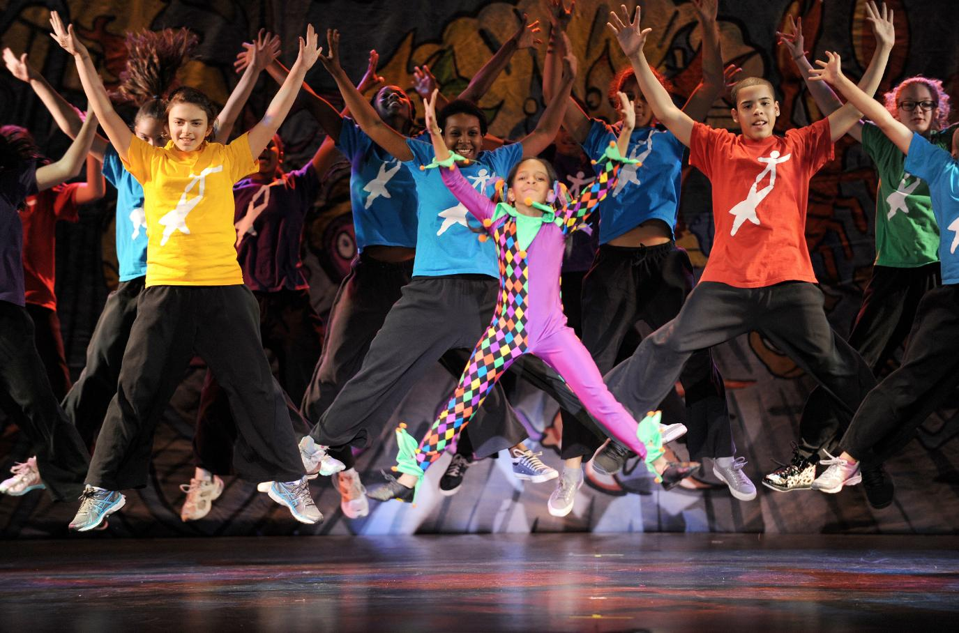One of the earliest dance outreach programs was created by Jacques d’Amboise, former principal dancer at the New York City Ballet. In his autobiography I Was a Dancer, d’Amboise remembers himself as “a wild, untamed youth who learned nobility through art.” D’Amboise grew up in Washington Heights, a rough area of New York City. He founded the National Dance Institute (NDI) in 1976 in order to provide free dance classes to New York City public school children. His goal in founding the NDI was to teach, inspire, and motivate city public school children like his former “wild” self. D’Amboise estimates that in the organization’s 37 year existence, more than two million children have been affected by it. He writes, “Once the children see that we are having a class of precision, order, and respect, they are relieved. It’s the beginning of dance. You cannot have a successful dance class without good manners, without respect. Dance can teach those things.”
I spoke over the phone with dancers, dance teachers, and directors of community dance programs throughout the country. They all agreed: Dancing builds discipline, teaches life skills, promotes self-confidence, and improves focus at school.
To read Part 2 for more real-life examples of how dance enhances cognitive skills, reduces stress and improves quality of life among children and adults, visit here.

Photo: Eduardo Patino, courtesy National Dance Institute
Veronica Hackethal is a dance, travel, and health writer based in New York City. She is a contributing writer to The Dance Enthusiast. Her writing has also appeared on Best Travel Writing, Literary Traveler, Transitions Abroad, Matador, and Inner Body. Awards for her writing include Silver Prize in Travelers’ Tales Solas Awards, Bronze Prize in Travelers’ Tales Solas Awards, and finalist in Transition Abroad’s Narrative Travel Writing Contest. Veronica began training in classical ballet at age six and danced into her teens. She took an extended hiatus from dance to attend Harvard University (A.B.), Oxford University (M.Sc.), and Columbia College of Physicians and Surgeons (M.D.). She returned to ballet five years ago. Veronica is the author of The Complete Idiot’s Guide to Medical Terminology, with publication by Alpha/Penguin projected for Summer 2013. She is also the recipient of a 2013 American Society of Journalists and Authors scholarship.

Come Dance With Me, part 2

June 20, 2013
Editor’s note: This article reflects on scientific and practical uses of dance and brain function. To read Part 1, visit here.
By Veronica Hackethal
Scientific studies among youth have shown that dance improves stress, depression, self esteem, motivation, and concentration at school. Dance can also improve creative thinking, problem-solving skills, and the ability to cope with stress for those suffering from a variety of illnesses, and can increase the general quality of life of people of all ages. Regular participation in dance may even help decrease the risk of developing dementia. You can read up on the science of the brain and how dance boosts brain power in Part 1 here.

Dancing Classrooms, New York, NY
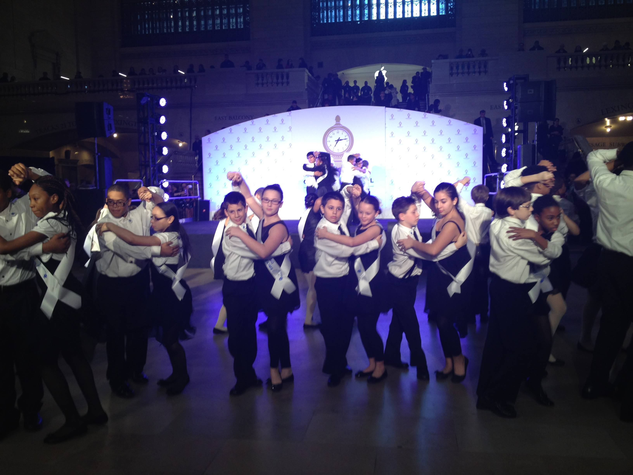Dancing Classrooms was founded in 1994 by Pierre Dulaine and his dance partner Yvonne Marceau, former Broadway dancers, and faculty members at the School of American Ballet and the Juilliard School. The 10-week, 20-session social-development program is intended for 5th through 8th grade public school children in New York City. According to the Dancing Classroom website, the organization’s goal is to “increase children’s self-esteem, confidence, responsibility, politeness, discipline, and social awareness, to breakdown social barriers, and to develop respect for others and for themselves through the medium of ballroom dance.”
Schools in 15 states nationwide have subsequently adopted the Dancing Classrooms model, which has also spread internationally to Canada, Switzerland, and Israel. During the 2010-11 school year, a total of 42,000 children in 509 schools received the Dancing Classrooms program. In New York City alone, more than 30,000 children in more than 200 schools participate in Dancing Classrooms each year.
Dancing Classrooms, perhaps the most widely known of youth dance programs, inspired the Antonio Banderas film “Take The Lead,” and was also the subject of the documentary “Mad Hot Ballroom.” The latter profiled the progress of several children from various backgrounds, from the beginning of dance classes to the culminating competition at the end of the program.
Children who participate in the Dancing Classrooms program can pursue further dance training through the Dancing Classrooms Academy weekend program, from which they can audition for the Dancing Classrooms Youth Dance Company. The Dancing Classrooms Youth Dance Company has performed on NBC’s “Today Show,” Kennedy Center’s 35th Anniversary Gala, PBS, and CBS’s “The Insider.” They have also performed at Madison Square Garden, Lincoln Center, and have appeared in the March 2008 issue of Vogue.
Rodney Lopez, national program director, described the benefits of Dancing Classrooms. “Ballroom requires kids to work together in a specific way that builds respect and self-confidence,” he said. “They are able to relate to their peers through dancing. Some kids have used dancing to come out of their shells and become more popular.” Lopez went on to describe opportunities that have opened up to some of Dancing Classroom’s participants. “For example,” he said, “the boy Wilson, who was featured in the film Mad Hot Ballroom, spoke at the Dancing Classrooms benefit gala last year. He has also received a scholarship to attend college in Massachusetts.” The program need not end at the conclusion of the 10-week session: “Dancing Classrooms participants can continue learning more advanced steps in the weekend academy,” he continued, “and they can audition for the youth dance company, which has performed at Lincoln Center with YoYo Ma and at the Jacob’s Pillow festival.”
Here’s what a fifth grade boy wrote about the program (as reported on Dancing Classroom’s website): “I learned to have respect for everyone in my class and I learned to behave in a gentlemen way and how to be nice and not mean to others and most of all not always think about myself but think about others around you.”

Village Dancers of Crossroads, San Francisco, Calif.
The motto of Village Dancers of Crossroads is “Effort, Respect, Reciprocity.” According to the organization’s website, the goal of Village Dancers of Crossroads is to be a “community-service learning program designed to help low-income kids and teens harness their personal power through movement, singing and dance performance.” Founded in 2000 by Albirda Rose, a dance professor, as part of the dance degree program at San Francisco State University, Village Dancers of Crossroads offers free lessons in jazz, ballet, hip hop, and other types of dance to children aged 8-18 who otherwise could not afford it. The program operates at six sites, and also teaches about diet and health.
Rose, is a master instructor in Dunham Technique, and uses Katharine Dunham’s model of “Socialization Through the Arts” and “Inter Cultural Communication” to train future dance teachers, as well to bring dance to youth in the community. Currently retired, Rose continues the program as faculty emeritus, and worries about its future.
In a phone conversation, Rose described some challenges the program faces. “One time,” she said, “there was a series of gang-related shootings. The kids were traumatized, and we were worried whether we should take the college dance education students to that area. But we did it, and it was a good thing. It gave the kids a break from the craziness.” Rose’s dedication to improving the futures of program participants became evident when she described one of the program’s success stories: a young woman who Rose took into her own home after the woman aged out of foster care. “There was a 14-year-old girl who came to the after school program and really wanted to be there,” she said. “At age 18, she aged out of foster care. She’s now 22 and she’s in community college. She was just certified to be a teen counselor.” Rose’s description clearly showed the pride she took in this young woman’s progress, perhaps aided by the structure and positive role models provided by Rose’s dance program.
Rose continued to explain how dance benefits youth, “Participating in dancing nurtures their ability to be independent, teaches them creative processing, and offers them an outlet for individual expression. Dancers have always known that everyone has their own special qualities. Dance allows [those] to come out,” she said. “Dance teaches them to be comfortable with themselves. It teaches them respect. I say, ‘If you don’t respect yourself, how can you give anyone else respect?’ It teaches them reciprocity. I say, ‘If I give you 100 percent, you better give me 110 percent back.’ It teaches them about effort and how to have a work ethic.”

Joy of Motion Dance Center, Washington, D.C.
The Joy of Motion Dance Center was founded in 1976 in Washington, D.C., and has several community outreach dance programs. Joy of Motion’s mission is “Dance is for Everyone,” and the goal is to encourage “participation in dance across the lifespan to develop better individual and community health and well-being.” Motion Express, one of its community outreach programs, offers a 20-week program of free dance classes, performances, and educational opportunities to economically disadvantaged children in order to promote positive growth and change. Over 400 students, from Pre-K to 12th grade, participate each year through D.C. public schools, D.C. public charter schools, and one community performing arts center. Associated programs at Joy of Motion include The Step Ahead program, which provides free summer dance classes and job skills training for D.C. teens. The Dance Is for Everyone program provides merit and needs-based scholarships to youths.
Joy of Motion is also a designated site for the Drug Enforcement Agency’s (DEA) Youth Dance Program, which provides free dance classes and opportunities for 4th through 6th graders at public schools to see dance performances. The aim is to encourage dance as a healthy alternative to drugs, alcohol, and violence. As one of the most successful after-school dance programs in the United States, the DEA Youth Dance Program reaches thousands of students each year in Washington, D.C., through JOM and 15 other cities nationwide, via other suitable dance providers.
Helen Hayes, program director of the Youth Dance Ensemble, is a former professional dancer who has won dance education awards, and has guest taught at the prestigious Varna International Ballet Competition in Bulgaria. She reinforced what science has to say about the benefits of dance. “Dance is transformative,” she said. “It builds strong bodies and minds. They way dancers process information is different from other physical activities. The brain is asked to work in a different way when you learn repertory and combinations. Dancing makes for a complete, whole, and healthy person. Dance addresses the body, mind, and soul. The level of integration necessary to be successful is very, very advanced. It’s win-win. Physical and mental skills increase. Self-confidence increases.”
She expanded on this to describe the social benefits of dance. “The feeling of creating a community every time they come into class,” she said, “participating in team building, having role models, and taking responsibility -- all of this helps create a better world, and better human beings.”
She also believes that dance teaches life skills. “Kids learn in every area of life. Former participants have told me that the time management and focus required in dance class taught them to be better in every area. The DEA Youth Dance Project kids find their own voices through dance. They create their own choreography and express what’s deep inside of them. They’re doing it in a healthy way, and coming to a safe environment.”
Joy of Motion’s outreach programs are designed to expose, employ and empower imagination of youth, explained Quynn Johnson, program manager of education and outreach at Joy of Motion. A dance teacher, choreographer, and a former member of Savion Glover’s tap dance company, Johnson also holds a BS in health management from Howard University. “The program teaches conflict resolution, nutrition, and positive health habits,” she said. “Students are encouraged to incorporate what they learn in dance class into their schoolwork.”
As a high schooler Brian Spitulnik danced in the Joy of Motion Youth Ensemble, a pre-collegiate dance training program. He subsequently completed college and currently lives in New York City, where he has danced in the Broadway musical “Chicago” since 2007. He also recently completed a masters in creative writing from Columbia University. Spitulnik emphasized the life lessons he learned at Joy of Motion. “Helen taught me how to have a work ethic and showed me that when things seem impossible, it just takes work,” he said. “Dance can be a great equalizer. Either your technique is there, or it’s not.” He further explained, “In the classroom, parental help, or being financially able to hire tutors, gives some people an advantage. In dance, I learned that what would help me move forward is my hard work. Other factors that would play into success outside the studio are stripped away. Inside the studio I’m just a boy in a leotard and what matters is my hard work.”
He also emphasized the importance of good teaching. “It can be a really scarring experience if you have the wrong teacher,” he noted. “Who your teachers are makes all the difference. Having that one really solid male figure allowed me to own whoever I was, within whatever I was doing.”
Spitulnik also emphasized the psychological rewards of dance: “It took me a long time to incorporate into other parts of my life the strength, confidence, and natural leadership qualities that I was able to develop at a dance studio. I learned things through my body before I knew them in my mind, which is how a lot of kids are. But it started with dance.”

DanceDC, Washington, D.C.
DanceDC is a community outreach program run by The Washington Ballet with the stated goal of creating higher achievement through ballet. Founded in 2000, Dance-DC provides 2nd and 3rd graders with a seven-week in-school curriculum that covers topics like ballet, music history, science and ballet, math and dance, introduction to world cultures, and language arts. Children also participate in daytime field trips to performances of The Washington Ballet and other recognized dance companies. The program concludes with a final performance given by the children. DanceDC operates in six public elementary schools, one charter school, and one community arts center in Washington, D.C. It reaches more than 500 children each year in District public schools. DanceDC also offers scholarships, sliding-scale tuition and financial aid for those DanceDC students who also attend dance classes at The Washington School of Ballet, or TWB@THEARC (The Washington Ballet at the Town Hall Education Arts and Recreation Center), located in Anacostia, a low-income area of the city.
In a telephone conversation, Saki Kawakita, DanceDC director, described the crucial importance of DanceDC programs, especially since D.C. public schools have lost physical education, arts, and music classes. She echoed Brian Spitulnik’s statement about children learning through their bodies. “Sometimes,” she said, “kids learn better from using their own bodies rather than a book. Some kids create their own choreography. Ballet or any other type of art helps them figure out who they are,” she said.
Kawakita explained how she teaches life lessons using fables. “For example, I took the texture from the fable ‘The Lion and the Mouse’ in order to teach children that the size of the body doesn’t matter. The idea of ballet dancers needing to be really tiny—breaking that is a big thing for boys. I show pictures of athletes and give them the idea that ballet isn’t only for a particular body type, or a certain gender, that it’s always good idea to try something new.”
Ballet improves academic performance, Kawakita said. “Teachers have noted better control in academic classes after ballet class, better control not only of the mind but also of the body. The children get the energy out of their bodies so they can sit down and do their schoolwork. They need an outlet. The first thing the teacher takes away from a trouble maker is recess. But trouble makers do really well in a ballet class,” she explained, “because they strive for recognition from the teachers. They pour their energy into the dancing. It gives them a sense of pride, and helps them to become better students.”

DanceSport Academy, Palm Beach County Florida
DanceSport Academy provides ballroom dance instruction to disadvantaged children in West Palm Beach, Fla. According to the organization’s website, the goal of DanceSport Academy is to encourage self-discipline, respect, and good manners, and to enhance young lives through the rigors of ballroom dance. DanceSport Academy, founded in June 2007, currently operates in four Boys and Girls Clubs throughout Palm Beach County, Florida. The DanceSport Academy program lasts 12 weeks and culminates in a competition between the four clubs.
In its five years of existence, DanceSport Academy’s impact has attracted national attention. Former Secretary of State Condoleeza Rice visited a DanceSport Academy class in March 2012, spending time with the children and dancing with the class instructor. Two DanceSport Academy graduates, Mark Wright and his sister Jameelah Grant, were provided with an expense-paid trip to San Francisco so that they could perform their award-winning tango at the Boys & Girls Club of America annual meeting in May 2008.
George Stamas is president, director, and co-founder of DanceSport Academy. A former banker and businessman in New York City, George Stamas is currently adjunct professor of finance and economics at Northwood University and Florida Atlantic University in West Palm Beach as well as a former navy officer. Stamas personally attends and supervises DanceSport Academy classes. “You can see the difference from when they start and when they finish,” he said. “I’ve had kids who were born crack babies. They come from broken and abusive homes. I’ve seen some boys who will literally run around in circles. By the end of twelve weeks they’re not running around in circles anymore. We help them understand that there’s a whole world outside the abusive home. You teach a kid respect and they listen to you.”
He further explained some of the challenges of the program: “Sometimes a boy won’t dance with a girl, maybe because of chauvinism or a history of abuse. We overcome these resistances with care, compassion, and discipline. We expand their horizons. Ballroom dancing helps these children feel better about themselves and feel better in society. The process of discipline, of learning these steps, also helps them in school.”

Come Dance With Me
In the 14th century the Persian Sufi poet Hafiz wrote these words:
The God who knows only four words
Not the word NO!
Not the word DON’T!
Not the words that cause disorder and conflict.
The God who knows only four words keeps repeating them-
COME DANCE WITH ME
COME DANCE WITH ME
COME DANCE WITH ME …
Perhaps Hafiz knew that the drive to dance, the sheer joy of it, has been passed down to us since the dawn of time. Ancient cave paintings from as early as 20,000 years ago depict dance scenes, though dancing may have existed far earlier. From the time when our earliest ancestors became capable of upright posture, dance has benefited the human mind and body. Science has added to this ancient wisdom by offering proof about the benefits of dance, while success stories of community dance programs bear this out. Perhaps one of the great hopes for the future of dance and for our children lies in this: that we listen to the wisdom of experience from our dance elders as well as the scientific evidence. It is indeed a precious gift to bestow upon future generations the appreciation and thrill inherent in the words: “Come dance with me.”

Photos: Helen Hayes with students from the Joy of Motion Youth Dance Ensemble, Washington, D.C., courtesy Joy of Motion

Dancing Classrooms event at Grand Central Terminal Centennial, courtesy Dancing Classrooms

Young dancers from DanceSport Academy, which provides ballroom dance instruction to disadvantaged children in Palm Beach County, Fla., courtesy DanceSport Academy

